Environmental Science NAME: ________________________
Serial Dilution lab DATE: _____________ period: ____
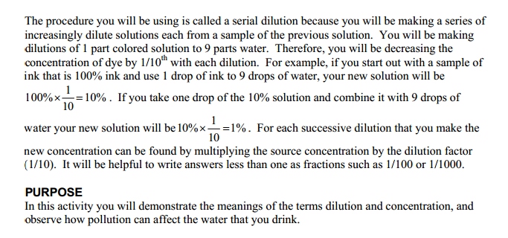
PRE-LAB (Read the Procedure before answering):
1. What is a serial dilution?

2. What will the concentration of solution be in each of the wells in the well plate? See procedure #’s 3-8 and the diagram.
Describe the unknown colored solution________________________
What will be in well plate #1_________________________
3. What is the dependent variable in this experiment?
4. What is the independent variable in this experiment?
5.Why do we take drops from the previous well?
6. How do serial dilutions help us understand LD50 for toxins?

7. Write a hypothesis about which solution you will use tomorrow in your LD50 lab. (choose from fruit punch soda, fertilizer, window cleaner , or other you choose to bring *prior teacher approval required).

.
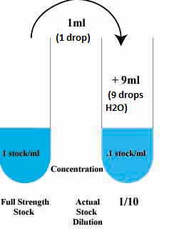
Equipment:
• 1 Chem plate (well plate)
• 1 graduated cylinder
- 2 small beakers
• water
- Unknown colored solution
- 2 Pipettes

1
control
3
2
Diagram 2
Complete diagram 2 by showing the steps required to prepare the control and well containers 1-3. Use arrows to show transfers of liquids and indicate the quantities of the solution being transferred. To the left of each container indicate the quantities of the fluids being poured into each container (like the example) To the right of each container indicate the final volume of the container. On the lines below the each container identify the concentration of the colored solution in the well.
10 ml from #1 to #2
9 mL water & 1 mL from #1
The control is your 100% unknown colored solution well
Procedure:

1.Measure 90 ml of water in a graduated cylinder. Pour 20 mL of water into a small beaker. Do not mix with anything else!
2. Get unknown colored solution from your teacher, put into the other small beaker. Stir. This is the control.
  - Use your pipette, drop 9 drops of water into well plate #1. Use the other pipette to drop 1 drop of the colored solution into well plate #1. Observe the color and record your results into the data table.
  - Add 9 drops l of water to well plate #2. Use the 2nd pipette, add 1 drop from container #1 to container #2. Record results
  - Add 9 drops of water to well plate #3. Using the 2nd pipette, add 1 drop from container #2 to container #3.
  - Continue until you get to well #10.
  - Complete the data table.

Data Table

Well Plate # | Color | Amount of H2O in mL  (1 mL=1 drop) | Amount of colored solution in mL (1mL=1drop) | Dilution Total Concentration in % and ppm/ppb
1
2
3
4
5
6
7
8
9
10
