Evolution and Ecology

- Define ecology -

- Ecologists organize life into these categories. Define each one.

  - Organism –

  - Population –

  - Biological Community –

  - Ecosystem –

  - Biosphere –

- Define habitat –

  - Give two examples of factors that can define a habitat.

- Define critical factor –

- Label the optimal range, zones of physiologic stress (x2), and zones of intolerance (x2) in the figure below.

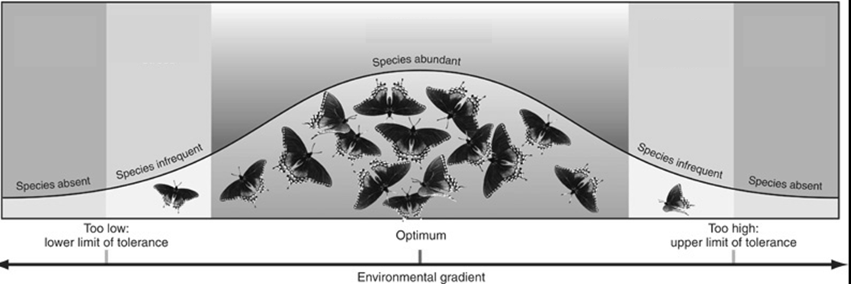
Evolution

- There are three types of adaptations seen in living organisms. Define each:

  - Physical adaptations –

  - Behavioral adaptations –

  - Physiologic adaptations –

- Define evolution -

- Define natural selection -

- What is the primary source of the genetic variety behind natural selection and evolution?

- Describe the three forms of evidence of evolution:

  - Physical similarities –

  - Comparing DNA –

  - Vestigial Structures –

- How is Sickle-cell anemia an example of natural selection in the human race? What advantage does it provide?

  - What geographic areas tend to have more people with the disease?

- Define divergent speciation –

  - Describe an example:

- Describe the four factors that will favor natural selection and speciation:

- Define convergent speciation –

  - Describe an example:

- Define artificial selection –

  - Describe an example:

- Within the biodiversity of the Earth, how many species are actually discovered? How many are hypothesized to exist?

  - The majority of known species are ________________.

Classification

- List the taxon that humans belong in for each of the different levels of classification. Give at least one reason why they are placed in each taxon.

 | Taxon | Reason
Domain
Kingdom
Phylum
Class
Order
Family

- The final two taxa are used to determine scientific name. What is the scientific name of the modern human? (Use the correct format)

- Two animals with many classification levels in common are considered to be ___________
_____________________.

Population Growth Patterns

- What shape does a logistic growth pattern take? Draw it on the graph to the right.

- What causes the population growth to slow down?

Density-Dependent Factors –

Density-Independent Factors –

- At what point do logistic growth curves eventually stabilize?

- What shape does an exponential growth pattern take? Draw it on the graph to the right.

  - What is missing that allows the population to grow so rapidly?

- Define and label overshoot.

- Define and label dieback.

Community Interactions

- Describe and give an example of each of the following types of community interactions:

  - Predator-Prey

  - Intraspecific competition

  - Interspecific competition

- How do plants and animals avoid competing with their own species? Give an example.

- Define and give an example of each of the following types of symbiosis:

  - Mutualism –

  - Commensalism –

  - Parasitism –

