rubric on page 2
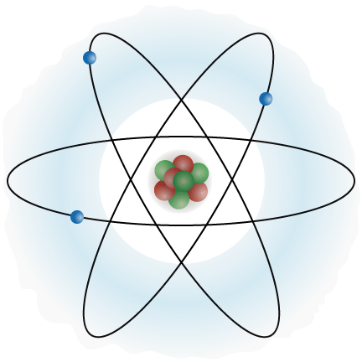  Elements Most Wanted  ELEMENT TILE ASSIGNMENT - RUBRIC  COMPONENTS / LAYOUT (each worth 1 point)  - Symbol is approximately 3” in height  - Symbol is centered.  - Element name centered under symbol.  - Atomic number correctly placed.  - Atomic mass correctly placed.  - Name is included on front bottom.  Awesome = 4 Admirable = 3 Acceptable = 2 Attempted = 1  Creativity - use 3 pictures/graphics to represent element qualities and information - appearance is unique - background and fonts are interesting  Information Information completely describes the element’s - uses - background / history / discovery - other interesting information  Integration Text is used with each graphic to explain its purpose / what it represents.  Clarity All information is clearly presented. Spelling and grammar is correct and everything is easy to see.  Accuracy All information is accurate.  25-26 = A+ (26 pts = 100%) 14-15 = C+ (20 pts = 77%)  23-24 = A (24.5 pts = 95%) 12-13 = C (19 pts = 75%)  22 = A- (23 pts = 90%) 10-11 = C- (18 pts = 70%)  20-21 = B+ (22 pts = 87%) 8-9 = D+ (17 pts = 67%)  18-19 = B (21.5 pts = 85%) 6-7 = D (16 pts = 65%)  16-17 = B- (21 pts = 80%) | Elements Most Wanted  ELEMENT TILE ASSIGNMENT - RUBRIC  COMPONENTS / LAYOUT (each worth 1 point)  - Symbol is approximately 3” in height  - Symbol is centered.  - Element name centered under symbol.  - Atomic number correctly placed.  - Atomic mass correctly placed.  - Name is included on front bottom.  Awesome = 4 Admirable = 3 Acceptable = 2 Attempted = 1  Creativity - use 3 pictures/graphics to represent element qualities and information - appearance is unique - background and fonts are interesting  Information Information completely describes the element’s - uses - background / history / discovery - other interesting information  Integration Text is used with each graphic to explain its purpose / what it represents.  Clarity All information is clearly presented. Spelling and grammar is correct and everything is easy to see.  Accuracy All information is accurate.  25-26 = A+ (26 pts = 100%) 14-15 = C+ (20 pts = 77%)  23-24 = A (24.5 pts = 95%) 12-13 = C (19 pts = 75%)  22 = A- (23 pts = 90%) 10-11 = C- (18 pts = 70%)  20-21 = B+ (22 pts = 87%) 8-9 = D+ (17 pts = 67%)  18-19 = B (21.5 pts = 85%) 6-7 = D (16 pts = 65%)  16-17 = B- (21 pts = 80%)

