Name: _____________________________________ Date: __________________ Period: _____

Completing a Circuit

Introductions

In this activity, you will investigate circuits, how they can be completed, and the flow of electrons through a circuit. Without a complete circuit, we would not be able to power light bulbs or any other electronics that we use today.

1. Open this link: https://phet.colorado.edu/en/simulation/circuit-construction-kit-dc-virtual-lab
2. Click “Run Now”
3. It will take time to load and then this screen appears:
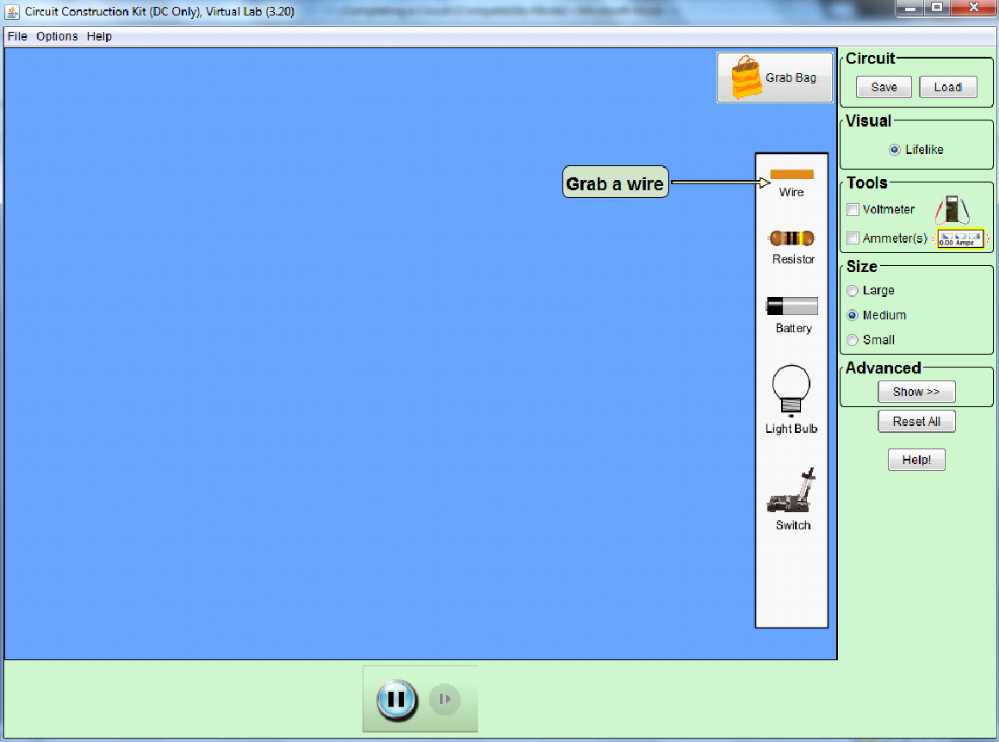

Exploration Phase (5-10 minutes)

- Click the “Help!” button on the right side of the screen to show helpful tips on how to work within the sim. Once you are comfortable with the controls, you may click “Hide Help”
- Drag and drop a light bulb into the blue area.
- Use wires and batteries to provide power to the bulb and make it light up.
- Experiment with different amounts of wires and batteries, as well as different arrangements for these items.
- Experiment with objects, such as the battery, by right clicking them. Batteries can be reversed and voltage can be changed.

Questions:
- What do you notice about the flow of electrons (blue circles) in a complete circuit?

- What happens when more batteries are added to the circuit?

- What happens when more wires are added to the circuit?

- What do you think the wires are made of?

- Does the arrangement of the objects within the circuit affect the circuit?

- How many ends do each part of the circuit (battery, wire, and bulb) have in which other elements can be connected?

Once finished with these questions, click the “Reset All” button on the right side of the screen.

Explanation Phase (25-30 minutes)
Aim: Describe the conditions required to complete a circuit. Explain your answer here and check with teacher before continuing.

The picture below provides an example of a compete circuit. Please create this circuit in your sim now.

- Explain why this system results in a complete circuit which lights the bulb and describe the flow of the electrons through the system.

- Right-click one of the batteries and then reverse it. What happens now? Explain.

- Reverse the other battery. What has happened now? Why? Do you notice any changes from the original setup of the system?

- Reverse one battery again. The result should be the same as that in number 2. Now right-click one battery and change the voltage to 18 volts. Describe what happens now and why it happens.

- Change the voltage of the other battery to 18 volts. Explain what happens.

- Create a circuit using a switch as shown in the picture to the right.
- Predict what position the switch will need to be in to complete the
circuit. Record your prediction here:

- Move the switch until the bulb is lit. Did this position match your prediction? Why do you think this position completed the circuit?

Apply (15-20 minutes)
For this phase, you will use your current circuit.

First, right-click and remove the switch. You should now have an incomplete circuit and the bulb should not be lit.
Next, right-click the battery and change the voltage to 100 volts.
What would happen if this was done while the circuit was complete?

Attach the wire to the battery to complete the circuit and compare the results to your prediction.

Detach the battery from the wire again by right-clicking the area where they connect and then clicking “split junction.”

Click on the Grab Bag button near the top-right corner of the screen. A screen should pop up looking like this:

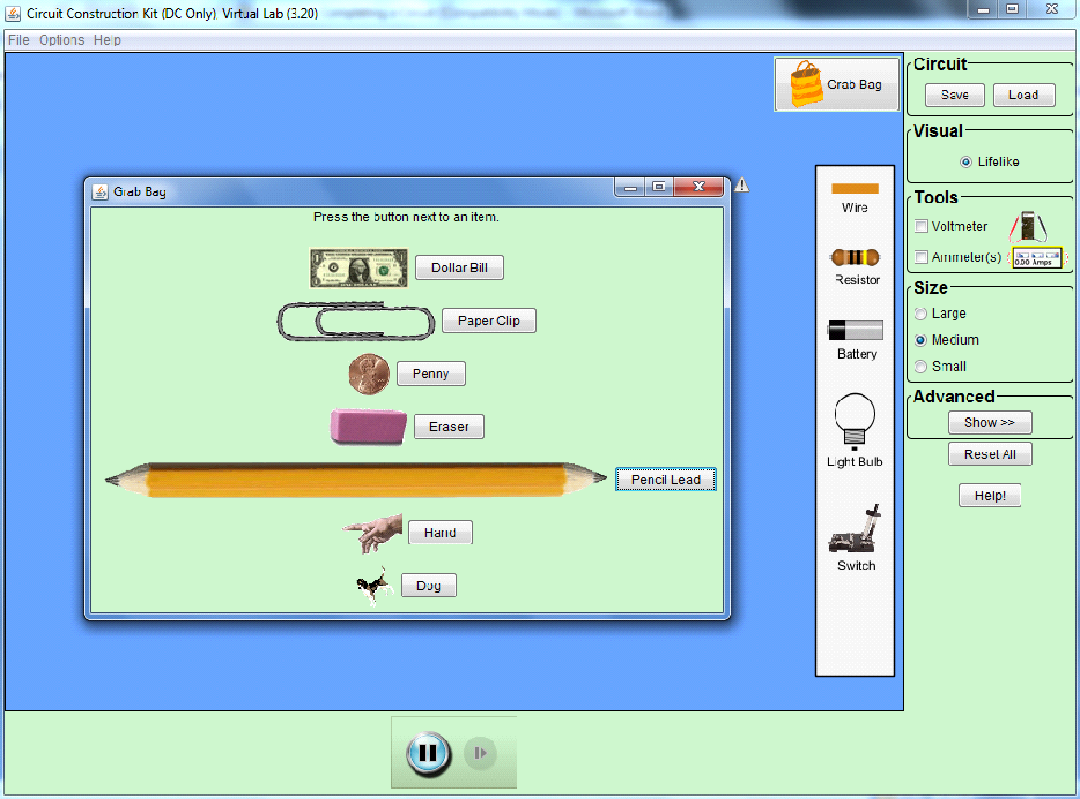
You will be replacing the switch that was removed with each of these items. In the table, predict which of these items will complete the circuit by recording “yes” or “no.”

Item | Completes Circuit?
Dollar Bill
Paper Clip
Penny
Eraser
Pencil Lead
Hand
Dog

Replace the switch with each item and record the actual results in the table below.

Item | Completes Circuit?
Dollar Bill
Paper Clip
Penny
Eraser
Pencil Lead
Hand
Dog

Describe any surprises that you encountered and why the results did or did not match your predictions.

Additional Information

- When an object placed into the circuit results in the bulb becoming lit, we can call that object a conductor.
- When an object placed into the circuit does not result in the bulb becoming lit, we can call that object an insulator.

Conclusions: What is required to create a complete circuit? How do the objects we insert into and adjust within a circuit change its behavior? Give specific examples using items that were applied and manipulated in this activity.

____________________________________________________________________________________________________________________________________________________________________________________________________________________________________________________________________________________________________________________________________________________________________________________________________________________________________________________________________________________________________________________________________________________________________________________________

