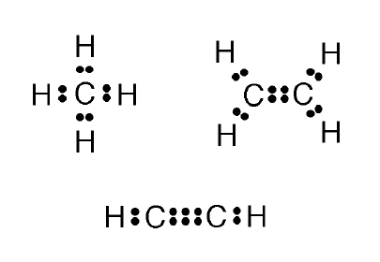
Bonding Practice

STEP 1: For each compound, decide whether it is ionically bonded or covalently bonded.
Label the bond type. How do I do this?

STEP 2: Draw the Lewis dot structure for each element.
How do I do this?

STEP 3: Ionic? Show movement of electrons AND label the charge on each atom.
Covalent? Make a second drawing showing electrons in the bonded molecule.

K₂O | SrF₂
CaBr₂ | I₂
CH₄ | MgF₂
HBr | FeO  (Fe = 2 valence electrons)
BaO | Challenge: C₂H₆

