Name: _ Date:
Environmental Science

Biogeochemical Cycles

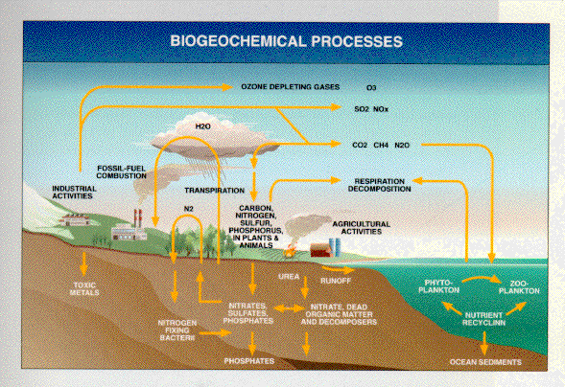
Objectives:
- Identify and describe the flow of nutrients in each biogeochemical cycle.
- Explain the impact that humans have on the biogeochemical cycles.

Do Now Questions
- What happens to energy in an ecosystem?

- What happens to matter in an ecosystem?

- What Sustains Life on Earth?

  - Solar energy: ______________________________________________________________________________
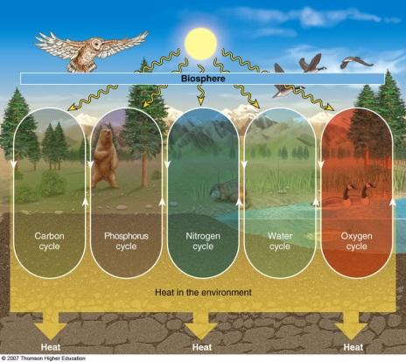

Two Secrets of Survival:
1. ______________________________________________

2. ______________________________________________

*An ecosystem survives by a combination of energy flow and matter recycling.
Ecosystems

- Ecosystem = ______________________________________________
- Includes _________________and _________________components
  - Energy flows and matter cycles among these components
- Biological entities are highly intertwined with chemical and physical entities
  - Interactions and __________________________________

The Earth’s systems
- System = ___________________________________________________________________________

  - Exchange of ___________________________________________________
  - Receives inputs of energy, matter, or information; processes these inputs; and produces outputs
- Systems often show behavior that is hard to understand and predict

  - “The whole is more than the sum of the parts”
    - Environmental entities are complex systems that interact with each other
      - For example, river systems consist of hundreds of smaller tributary subsystems
  - To solve environmental problems, all appropriate systems must be considered
        - Lithosphere = rock and sediment
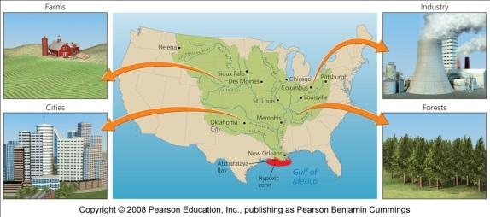
        - Atmosphere = the air
        - Hydrosphere = liquid, solid or vapor water
        - Biosphere = all the planet’s living organisms and the abiotic portions of the environment

MATTER CYCLING IN ECOSYSTEMS
- Nutrient Cycles: ________________________
- __________________________________________________________________ (Atmosphere, hydrosphere, lithosphere, and biosphere).
  - Nutrients are the elements and compounds that organisms need to ________________________________________________________________
  - Biogeochemical cycles move these substances through air, water, soil, rock and living organisms.
- Biogeochemical: ___________________________________________________________________________

___________________________________________________________________________
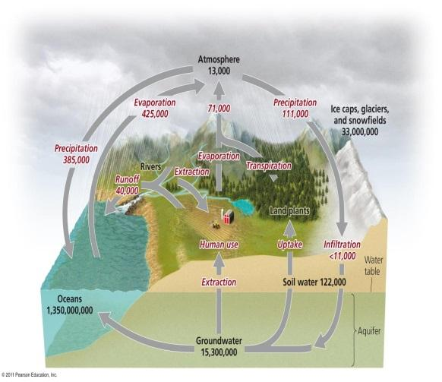
- Water’ Unique Properties
- There are strong forces of attraction between molecules of water.
- Water exists as a liquid over a wide temperature range.
- Liquid water changes temperature slowly.
- It takes a large amount of energy for water to ________________.
- Liquid water can ________________a variety of compounds.
- Water ________________when it freezes.

The hydrologic cycle
- Water is essential for ________________reactions
  - It is involved in ________________________________________________

- Hydrologic cycle = ___________________________________________________________________________

___________________________________________________________________________

  - Transpiration: _____________________________________________________________________
  - Groundwater
    - Aquifers = _______________________________________________________________
    - Groundwater = ______________________________________________________________
    - Water table = _______________________________________________________________
      - Water may be ancient (thousands of years old)

- Groundwater becomes exposed to the air where the water table reaches the surface
  - Exposed water ________________________________________________

- Effects of Human Activities on Water Cycle
  - We alter the water cycle by:
    - _________________________________

    - _________________________________

    - _________________________________

The carbon cycle
- Carbon is found in carbohydrates, fats, proteins, bones, cartilage and shells

- Carbon cycle = ___________________________________________________________________________

___________________________________________________________________________

- Photosynthesis by plants, algae and cyanobacteria

  - _______________________________________________________
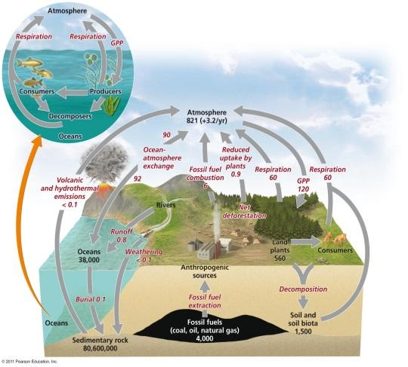
  - Produces oxygen and carbohydrates
  - Plants are a major reservoir of carbon

- Respiration returns carbon to the air and oceans

  - ____________________________________________

- Sediment storage of carbon
  - ______________________returns carbon to the sediment
  - The largest reservoir of carbon
  - May be trapped for hundreds of millions of years

- _________________________________die and settle in the sediment
  - Older layers are buried deeply and undergo high pressure
  - Ultimately, it may be converted into _________________________________

- _________________________________are the second largest reservoir of carbon

- Effects of Human Activities on Carbon Cycle
  - We alter the carbon cycle by adding excess CO₂ to the atmosphere through:
    - ____________________________________________

    - ____________________________________________

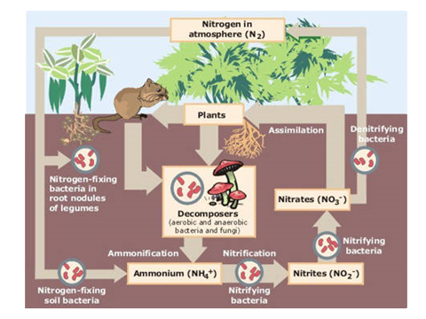

The nitrogen cycle
- Nitrogen comprises ________% of our atmosphere
- It is contained in ________________________

- Nitrogen cycle = ___________________________________________________________________________

___________________________________________________________________________

- Nitrogen fixation = _______________________________________________________________________

  - To form ________________________
  - Which can be used by ________________________

Nitrification and denitrification
- Nitrification = ___________________________________________________________________________
  - Plants can take up these ions
  - Animals obtain nitrogen by eating plants or other animals
  - Decomposers get it from dead and decaying plants or other animals
    - Releasing ammonium ions to nitrifying bacteria
- Denitrifying bacteria = ________________________________________________________________________
  - Releasing it back into the atmosphere

  - Effects of Human Activities on the Nitrogen Cycle
    - We alter the nitrogen cycle by:
      - ________________________________________

      - _________________________________________________________
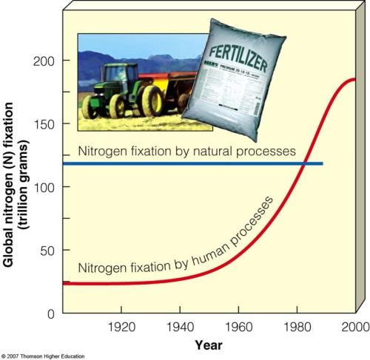
_________________________________________________________

      - _________________________________________________________

_________________________________________________________

      - _________________________________________________________

- Human activities such as production of ________________________now fix more nitrogen than all natural sources combined.

The phosphorus cycle
- Phosphorus (P) is a key component of cell membranes, __________________________

- Phosphorus cycle = ___________________________________________________________________________

___________________________________________________________________________

- Effects of Human Activities on the Phosphorous Cycle
  - We remove large amounts of phosphate from the ______________________________
  - We reduce phosphorous in tropical soils by ____________________________________
  - We add excess phosphates to aquatic systems from ______________________________
