7.3 Billion Reasons to know about the world
Populations Studies Project Due Date: January 23, 2017
The United States is one of over 190 different sovereign countries that exist in today’s world. Many of these foreign countries are quite different from the United States. Some of these nations are currently dealing with significant social issues. To help you gain some perspective on these challenges you are going to adopt a country. You will be assigned either to choose from Group A or a country from Group B. Once you have adopted your country, go to Wikipedia (en.wikipedia.com) and enter the name of your country in the search box. The rest of the date will come from a different website: http://www.census.gov/population/international/data/idb/informationGateway.php
Once you have the data you need, you will create a book to introduce the class to your country. This will count as a Class 1 assignment.
Use this guide for each page of the book.
Page 1-Table of Contents
Page 2-Map of the world with your country colored in. (Cut out the template attached)
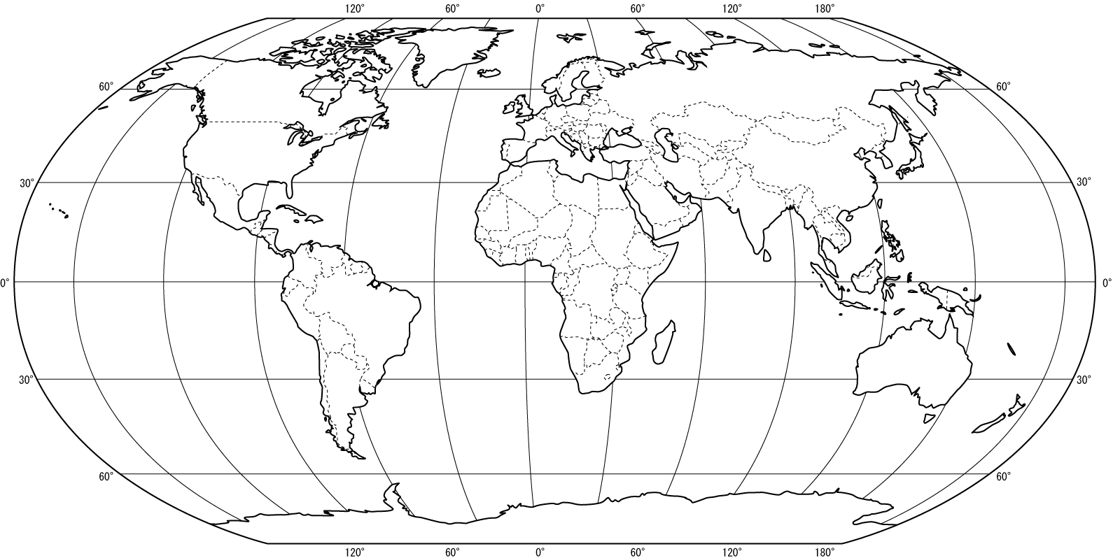

Page 3-Picture of an interesting geographic location in your country (you can use google images). Be sure to give the location under your image.

Page 4--Demographic Overview Data (use www.wikipedia.com for this section) ( you can cut this out and paste in your book.)
Country Name______________________________________
Capital City-

Official Language
Official Currency
GDP (Gross Domestic Product Per Capita)
Total Land Area (mi²)

Page 5 Picture of the people of your country (use google images ) ( Be sure to caption your image)
The rest of the date will come from a different website: http://www.census.gov/population/international/data/idb/informationGateway.php
Page 6-Demographic Overview
Select demographic overview and the year 2017 and select your country. Click submit.
Copy the data for the following:
Population
- MIDYEAR POPULATION __________________
- GROWTH RATE_________________________
Fertility
- Total Fertility Rate_____________________________
- Crude Birth Rate______________________________
- Crude Death Rate_____________________________
Mortality
- Life Expectancy____________________________
- Infant Mortality Rate_______________________
- Under 5 years mortality rate_________________
- Crude Death Rate__________________________
- Deaths__________________________________
Migration
- Net Migration Rate______________________________
- Net Number of Migrants_________________________
On page 6 also, make a line graph on graph paper that shows the population growth from 1967-2017 (record the population for each 10th year) Select Populations Data . Select the following years. Click submit
1967 | 1977 | 1987 | 1997 | 2007 | 2017

Page 7-Population Pyramid for the year 2016 (Select Report for population pyramid, select year 2017 and select your country. Click submit) Use graph paper to make a graph with a title, labeled axis and color coded)
Page8-Answer the following Questions- Title the page Analysis of Population Data for the Year 2016
- Explain the population pyramid graph in terms of births, deaths, and population:
- Describe the conditions of life: youth, working group and elderly
- What has to happen so that a country can transition to the next stage
Page 9 Economic Impacts Question and Answer
- If you had a business and wanted to capitalize on your information about the population age distribution in your country, what would you sell? Why?
Page 10 Population Impacts and Answer
- If you were a national leader in least developed country like Kenya or Iraq, would you be concerned about the rapid population growth? Why or why not? Similarly, if you were a national leader in a developed country like Italy or Japan with zero population growth or a declining growth? What do you think the impacts will be in 50 years?
Page 11- Pick ONE of the topics below, find a news article on the topic. Be sure to cite the source. Use the graphic organizer on the next page to help you organize your thoughts on the article. Write a paragraph summarizing the information you collected on the graphic organizer.
• Air pollution in fast-growing cities | • Legislation to provide insurance coverage for contraceptives | • Efforts to establish nature reserves in developing countries
• Urban sprawl and the loss of rural areas | • Power shifts as populations change | • Traffic congestion and “road rage”
• Food and water shortages around the world | • Challenges in completing an accurate Census | • Overfishing

